**Executive Summary**: A Journey into TravelTide's Customer Base

**Setting The Scene**

It was just another day at TravelTide when Elena approached us with a hypothesis about our customer segments. In a bustling world of travel, understanding our customer segments isn't just about numbers on a spreadsheet. It's about stories, journeys, and the individual preferences that make each travel experience unique. With Elena's ideas in mind, we embarked on a mission to unveil the real stories behind our data.

**The Characters of Our Tale**

After applying the cutting-edge k-means clustering method, the data started speaking to us in voices, painting vivid portraits of our diverse travelers:

*The Thrifty Travelers*

These 1,769 members are the smart savers, always on the lookout for value. They're not so keen on flights, but they do have an eye for a good hotel deal. What if we offered them 'No Cancellation Fees'? It’s a simple gesture that could mean a lot to them.

*The Luggage Leaders*

The 1,494 members in this group are all about that extra luggage space. They might not be frequent fliers, but when they travel, they pack! 'Free Checked Bag' might just be the perk that keeps them booking with us.

*The Luxe Lodgers*

A group of 572 who spare no expense for a luxurious hotel stay. With an average hotel fare of $332, how about enhancing their experience with a 'Free Hotel Meal'?

*The Diverse Jetsetters*

With 278 members, they’re the jack-of-all-trades travelers. Flights, hotels, you name it, they book it. Let's entice them with 'Exclusive Discounts on Flights' to nudge them towards their next adventure.

*The High-Rolling Experimenters*

A special group of 8 members, they’re few but pack a punch in spending. Their interests are varied, and perhaps a '1-Night Free Hotel with Flight' perk would pique their interest?

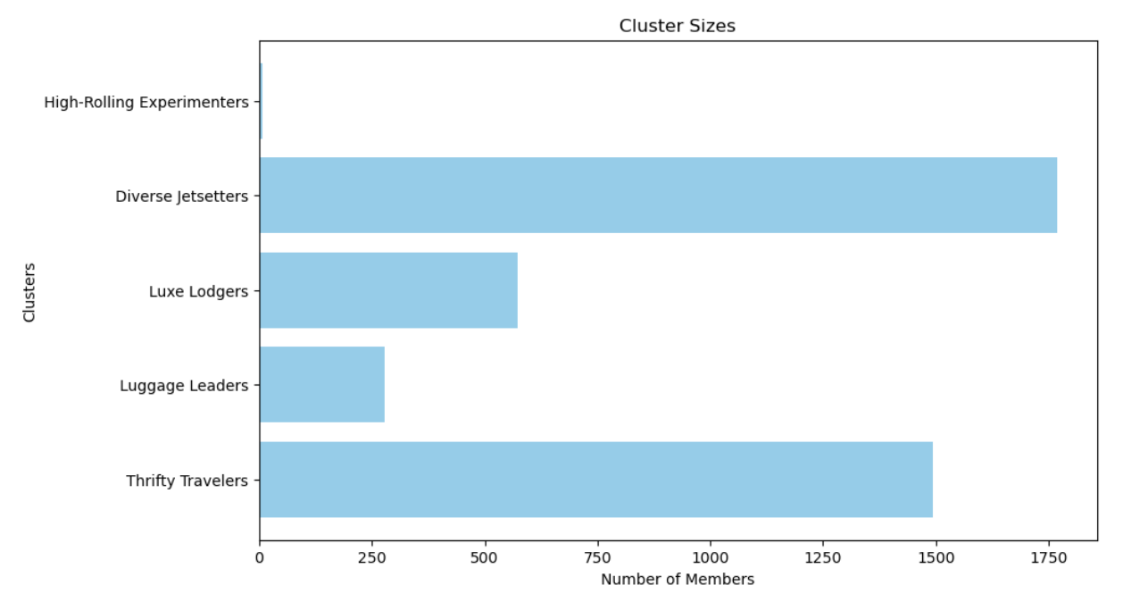

**Unfurling the Road Ahead**

But our journey doesn't end with just knowing our travelers. How do we keep the conversation going?

Targeted Marketing Campaigns: Each traveler has a story. Let’s craft messages that resonate with their unique tales.

Customer Feedback Loop: Just like any good story, there are always twists and turns. Let’s keep our ears to the ground and continually adapt.

Monitor and Update: The world of travel changes rapidly. We should always be ready to refresh our offerings.

More Layers to the Story: Let’s dive deeper, integrating behavioral and demographic data to truly get to know our travelers.

**The Final Chapter (For Now)**

As the curtains close on this chapter of our analysis, I'm filled with gratitude. Elena's initial musings have transformed into actionable insights. At TravelTide, we’re not just in the business of travel. We’re in the business of stories. With these newfound insights, we are better poised to enrich the tales of our diverse customer base, paving the way for mutual satisfaction and growth.